Fishbowl worksheet
The fishbowl technique was developed largely in clinical psychology practice as a new co-creative think tank helping people to get from insight, to ideas, to evaluation of those ideas in just a single session.

In the traditional Goldfish Bowl a small group of people discuss a scenario or case study whilst being observed by an outer ring of people, who reflect on the discussion individually from their own perspectives. The groups then swap over, with the outer group coming into the middle and sharing their thoughts on what they saw, heard and felt during the discussion. Finally, the whole group discusses the issue, capturing key learnings and conclusions.

The fishbowl is a technique to enable simultaneous internal and external observation. By switching observational points of view, the range of perspectives can be increased. Gathering the perspectives together at the conclusion of the fishbowl, provides a rich data set and greater insight

There are many different versions of doing the fishbowl activity, and this worksheet is one of the ways to do it. This method was chosen because it can involve a large group together in one activity and allows everybody the opportunity to speak, listen and make decisions. It encourages reflection and promotes understanding of individual perspectives.

Process:

The room needs to be set up with chairs in two circles (or whatever shape fits in your room) with the same amount of chairs in the inner and outer circle. Ask all attendees to sit on the chairs all facing inwards (e.g., a group of 40 people should have 20 in each circle). Ask participants to have their notepads and pens with them.

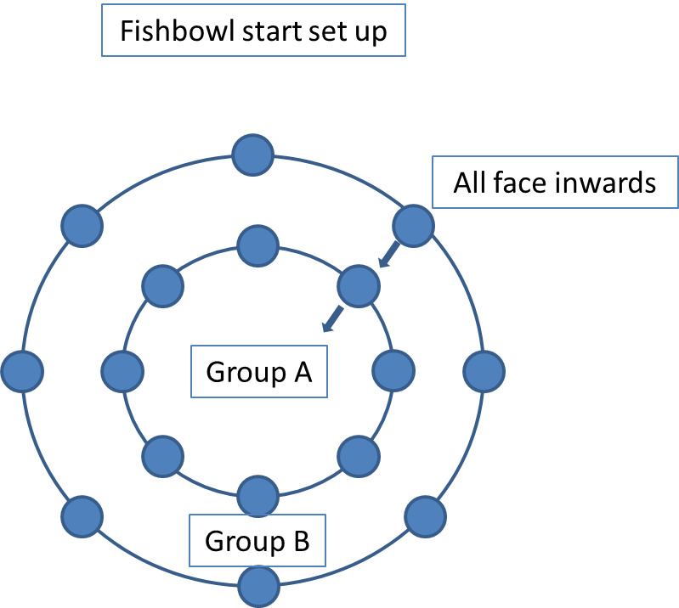

Phase 1 (10 mins)
- Group A (inner circle) discusses question 1 together: e.g., “What are the difficulties of working with your co-creators?”
- Group B (outer circle) listens and makes notes

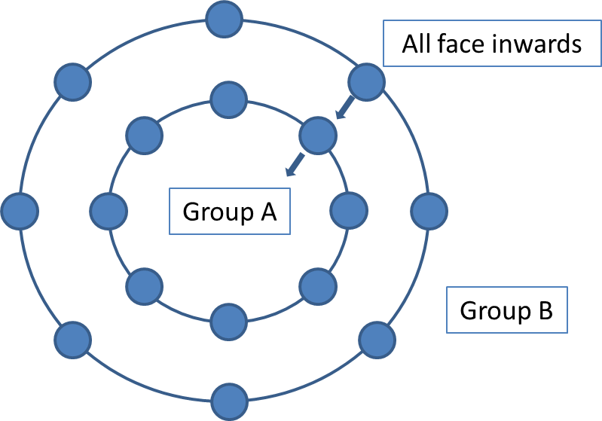

Phase 2 (10 mins)
- Group A and B swap places
- Group B (inner circle) discusses question 2 together (in light of group A’s discussion): e.g., “What competencies are needed to support and mediate communication with co-creators?”
- Group A (outer circle) listens and makes notes

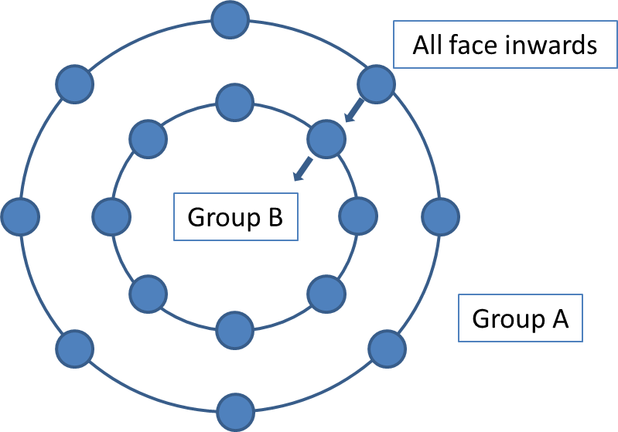

Phase 3 (10 mins)
- Group B turns their chairs to face group A
- Group A and B discusses the final task together (in light of group A and B’s discussions): e.g., “Decide on the top 5 competencies you think is needed to support and mediate communication with co-creators”
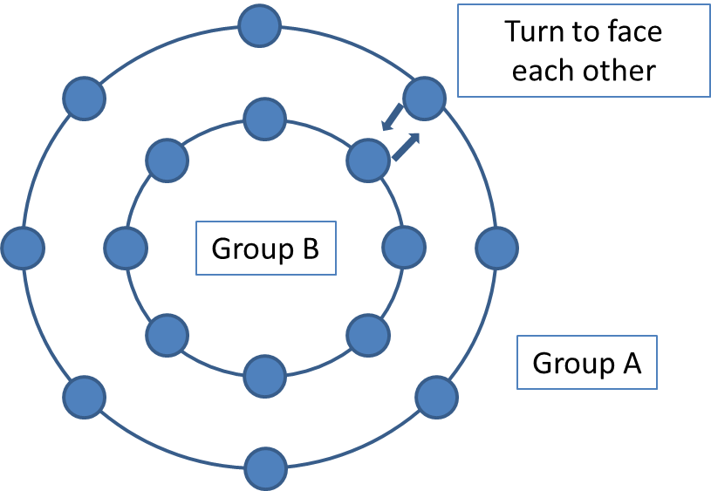

The facilitators can then turn these top 5 competencies into a word cloud if they wish.

Alternative ways of delivering this fish bowl technique:

- This fishbowl technique has also been used so that group A are one type of co-creator (e.g., patients or students) and group B are a different type of co-creator (e.g., staff). In this scenario, usually group A and B are asked to discuss the same question in phase 1 and 2 (this often helps to emphasise people’s needs and constraints as separate groups), and then come together in phase 3 to agree on solutions together (taking into consideration the needs and constraints discussed).
- If you are tight for space you can try splitting the room up and arranging smaller groups (for example around the already existing tables).

Materials used from the Erasmus+ funded Co-Creating Welfare project delivered by Coventry University http://www.ccw-project.eu/

